REPORT
The Botany Department of Goalpara College organized an educational excursion to the picturesque hill station of Darjeeling, West Bengal, from 26th to 29th October 2023. The trip aimed to provide students with practical exposure to the diverse flora and natural beauty of this region, enabling them to enhance their knowledge and understanding of botany.

Itinerary:
Day 1: Departure from Goalpara College, Assam
Day 2: Visit to the Tiger Hill and Peace Pagoda, Padmaja Naidu Himalayan Zoological Park and Exploration of tea gardens and tea processing factories
Day 3: Visit Nepal Boarder, Pashupati temple and market and finally Mirik Lake and return to NJP
Day 4: Departure to Goalpara
Experiences and Highlights:
Tiger Hill and Peace Pagoda: Early morning visit to Tiger Hill provided students with breathtaking views of the sunrise over the Himalayan peaks, including the majestic Mt. Kanchenjunga. The Peace Pagoda visit allowed students to understand the significance of peace and harmony in nature.
Padmaja Naidu Himalayan Zoological Park: The students had a fantastic opportunity to observe and study a wide variety of Himalayan fauna, including the critically endangered Red Panda. The visit allowed students to learn about animal behaviors and their natural habitats.
Tea Gardens and Factories: Darjeeling is renowned for its tea plantations, and the students visited tea estates and processing factories. They learned about the various stages of tea production, from plucking the tea leaves to packaging.
Educational Value:
The excursion allowed students to apply their theoretical knowledge in a real-world setting. They could correlate their classroom learning with practical observations, which is crucial for a better understanding of botany and the environment.

Challenges:
The excursion faced some logistical challenges due to the hilly terrain and limited accessibility to certain locations. However, these challenges provided students with a valuable lesson in adaptation and problem-solving.

Conclusion:
The Botany Department field visit to Darjeeling was a resounding success. It not only enriched the students' understanding of botany but also provided them with a unique opportunity to explore the rich biodiversity of the region. The trip was an educational adventure that will have a lasting impact on the participating students. It would not have been possible without the dedication of the faculty, the cooperation of the students, and the support of the college administration. We look forward to more such trips in the future.
View Point, Tiger Hills, Darjeeling
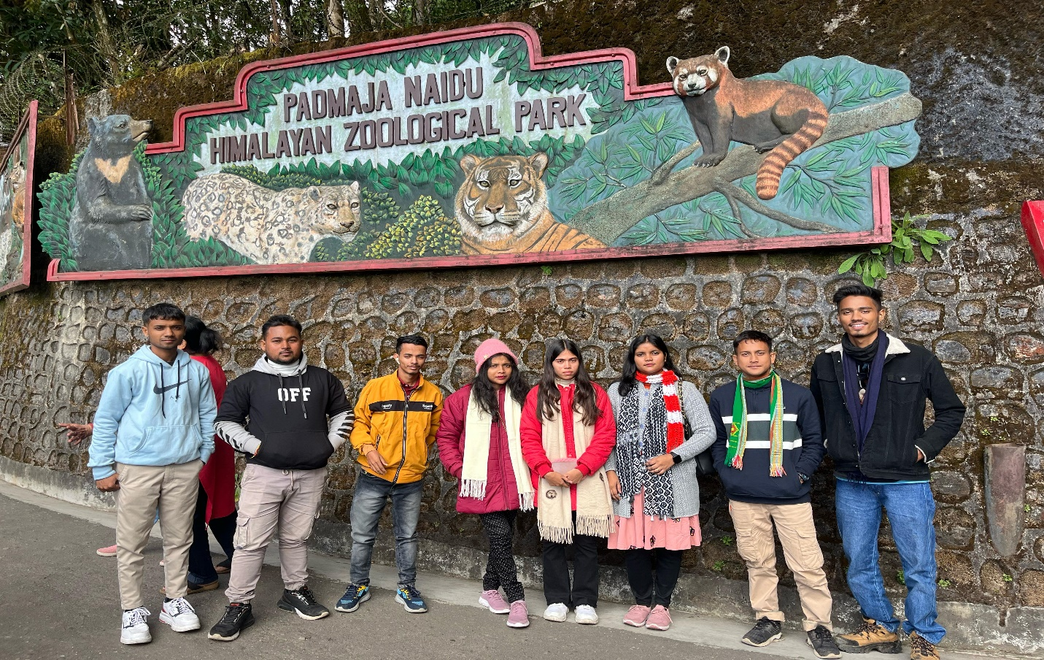
Padmaja Naidu Himalayan Zoological Park, Darjeeling
Mal Market, Darjeeling
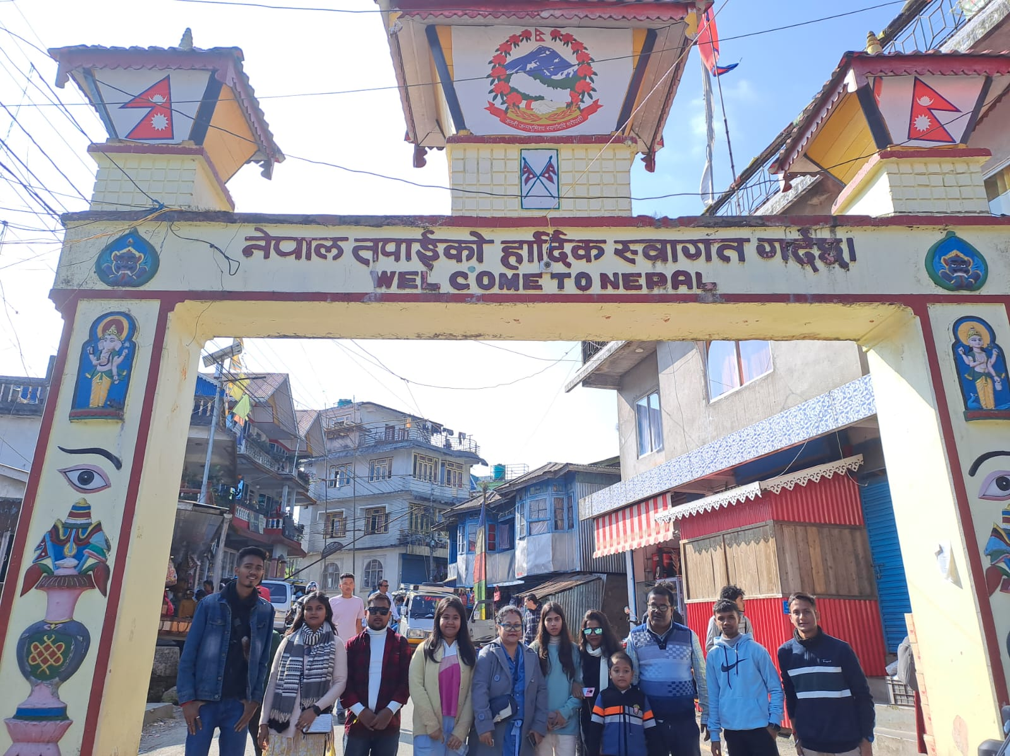
At the Nepal border, Pashupati Temple and Market

