REPORT

Department of Botany organized a Quiz Competition “How Much Do You Know” among the students of the department on 21st January 2021to add fun to learning. The students were quizzed on current affairs mainly focusing on biodiversity. Winner were awarded with framed photographs of beautiful Bioreserves. The competition was inaugurated by our GB President Dr. BK Nath and our Principal Dr. Subhash Barman.

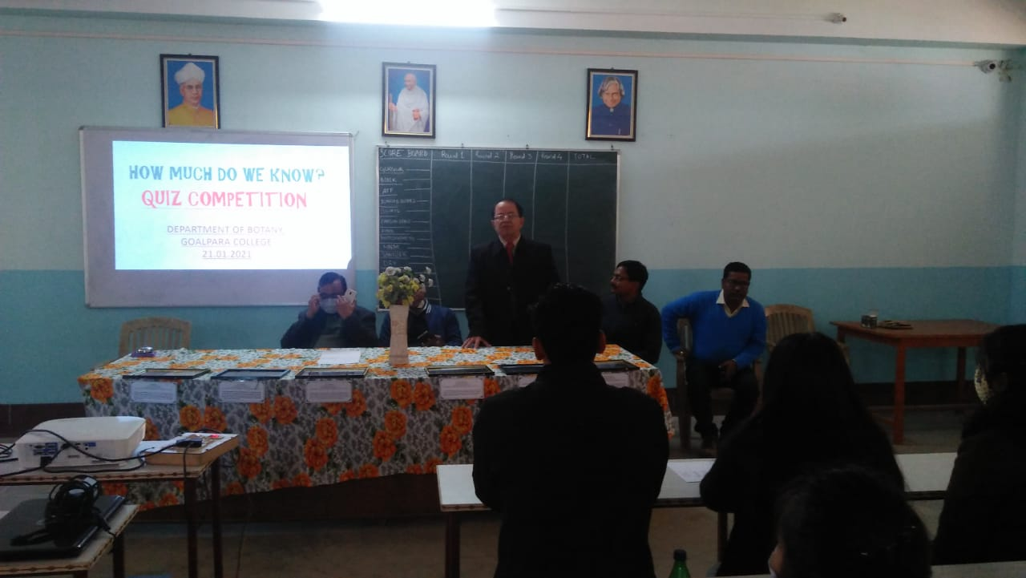
In frame from Left to right Dr. SN Sarma, Vice Principal, Goalpara College, Dr. Subhash Barman, Principal, Goalpara College, Dr. BK Nath, President, Governing Body, Goalpara College, Dr. S. Rao, HOD, Botany Department, Dr. DC Baruah, Assistant Professor, Department of Botany, Goalpara College on 21/01/2021: Quiz Competition.
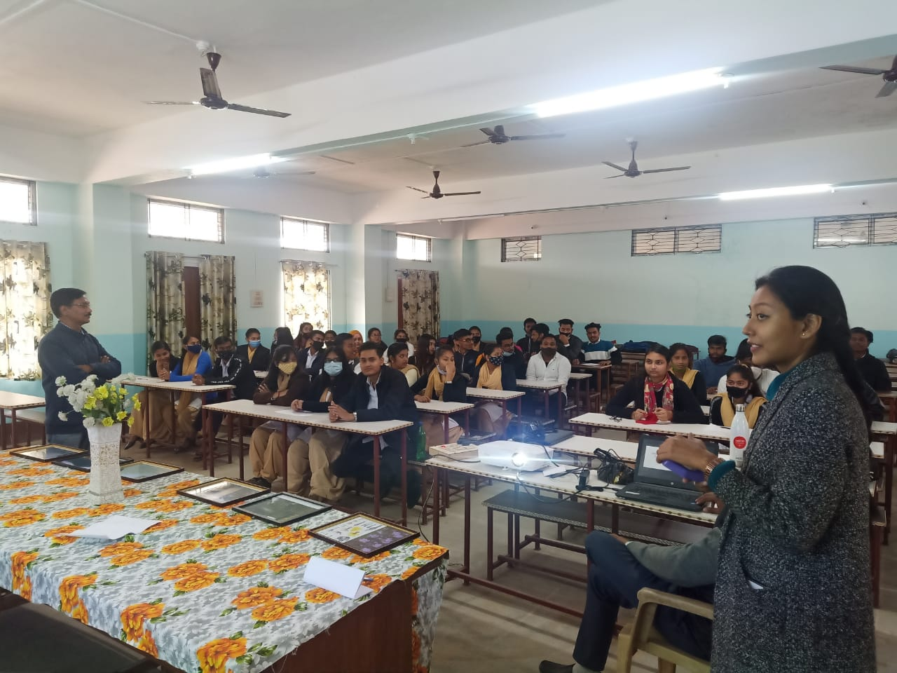
Students engaged in listening to question during the AudioVisual Round of Quiz Competition on 21/01/2021.

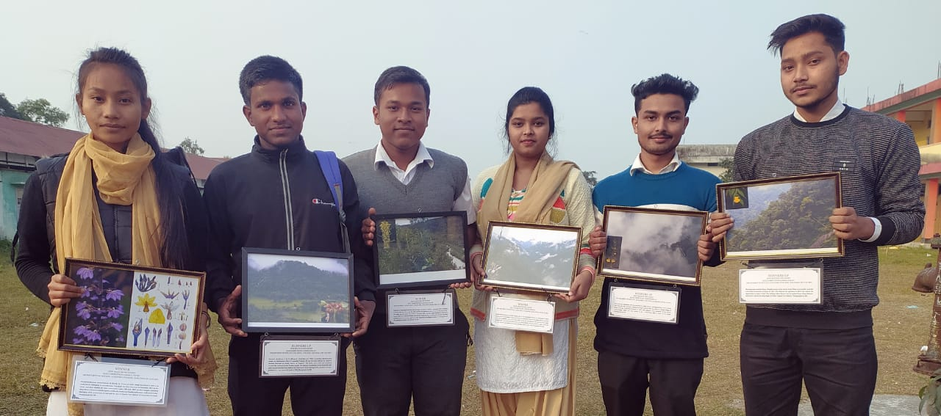
Winners of the Quiz Competition Organized by Department of Botany, Goalpara College on 21/01/2021.
In frame from left to right Hemoprabha Rabha (2nd Semester), Sobder Ali (4th Semester), Neelmoni Das (4th Semester), Mehnaz Safin Mondal (6th Semester), Bishal Das (6th Semester), Jitumoni Nath (2nd Semester).

