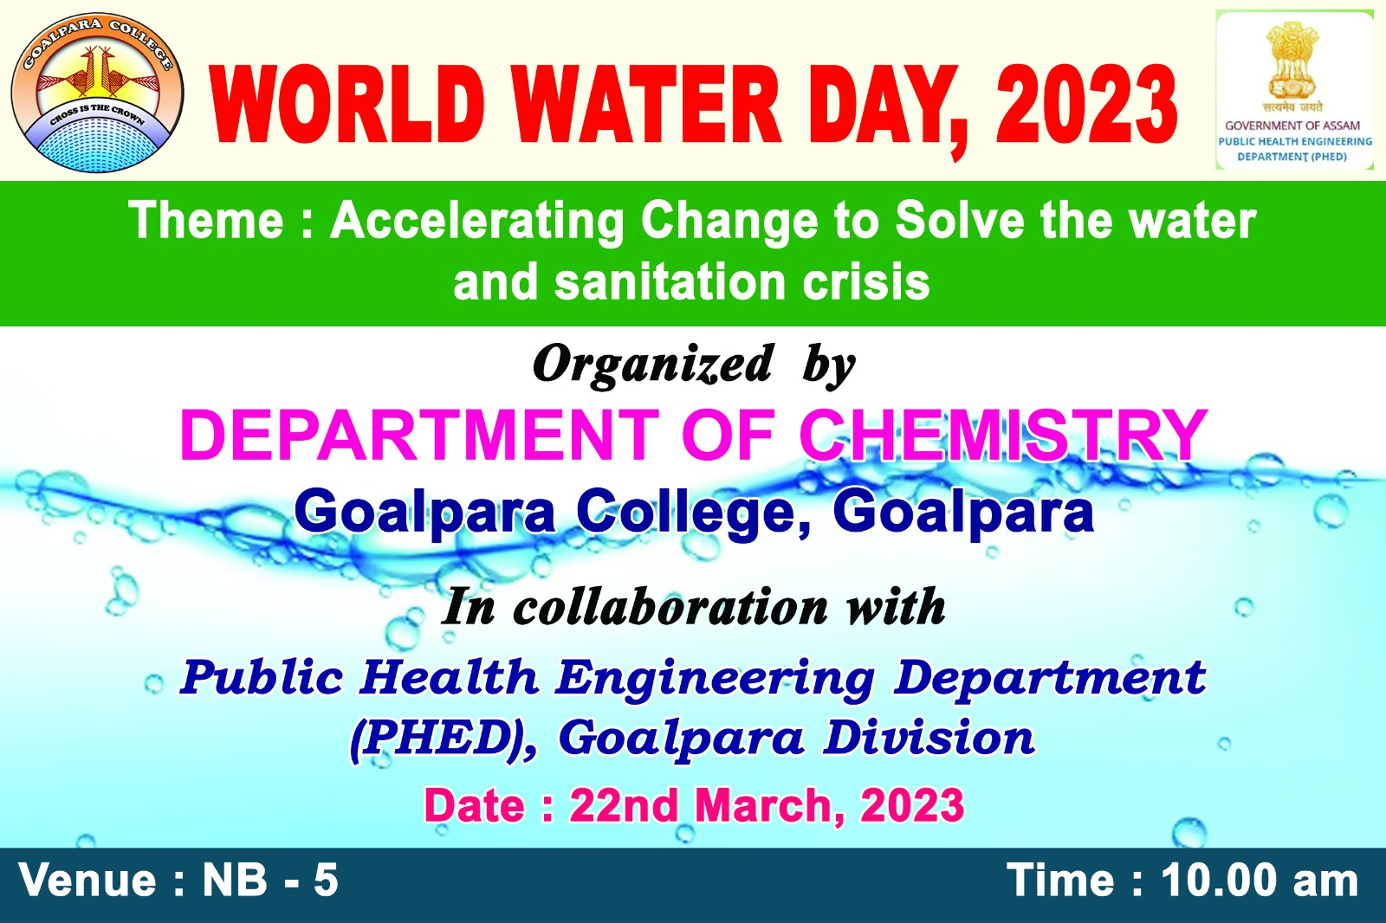

A half day long programme was organized by Dept. of Chemistry, Goalpara College on occasion of World water day. The programme was presided over by Dr. A. H Khan, HOD, Dept. of Chemistry, Goalpara College. A demonstration of water testing (P^{H}, Chloride, Turbidity, and Iron) was performed by representative from PHE, Goalpara Division. A talk was delivered by Dr.VelentinaBasumaray on water use and conservation. Principal of Goalpara college Dr. Subhash Barman and IQAC Coordinator Dr.Dulal Chandra Borah was also present in the meeting.
