Brief Report of the Department during Sept. 2020 to March 2021
- Preparation of the syllabus according to semseterwise though virtual conversation on 19 September 2020
- Organizing a faculty meet on 21st September for distribution of the syllabus according to contents among the teachers
- Distribution of classes according to class routine
- Meeting with the students on 11 November 2020 for arranging Get Together with new students and inauguration of the Book and wall magazine. Keeping the view of the Students academic involvement and writing skill in different field like Prose, Poetry, Treatise, Essay. Art etc Department has orgainsed a meeting with the students for necessary development of the Programme for Wall Magazine. Meeting also discussed for Get together Book Inauguration and opening wall magazine relating to students write-up. In occasion of book Inauguration Professor Dr. Bivash Choudhury Department of English Guahati University was present as Inaugurator along with the president of Governing Body Dr, Binoy kumar Nath and Principal Dr. Subhash Barman. Here some photographs to highlight the programme.
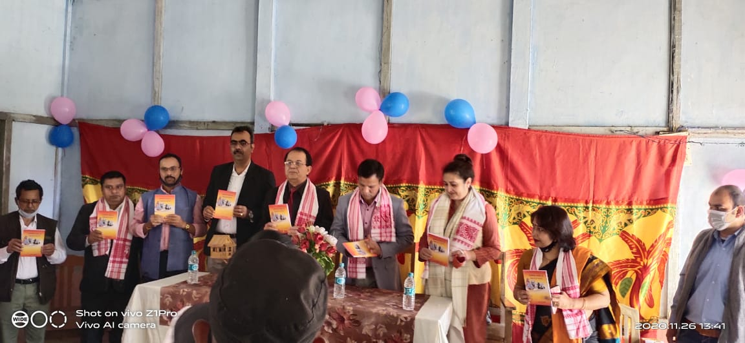

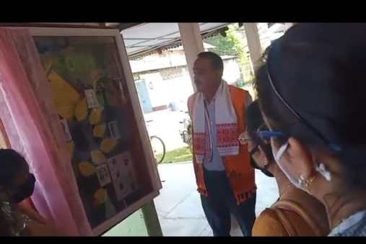
- Department has been organizing seminars, workshops, group discussions among the students in every year in order to promote academic side of the students. Students are asked to read out the papers written by themselves in front of Faculties and students. After read out each paper the chairperson open the papers for discussion among the students. It is found that students interaction was very very interesting. The following represents the facts.

a/ Seminar 19/01/2021, Students Present-48 Paper Readers in Group Three.

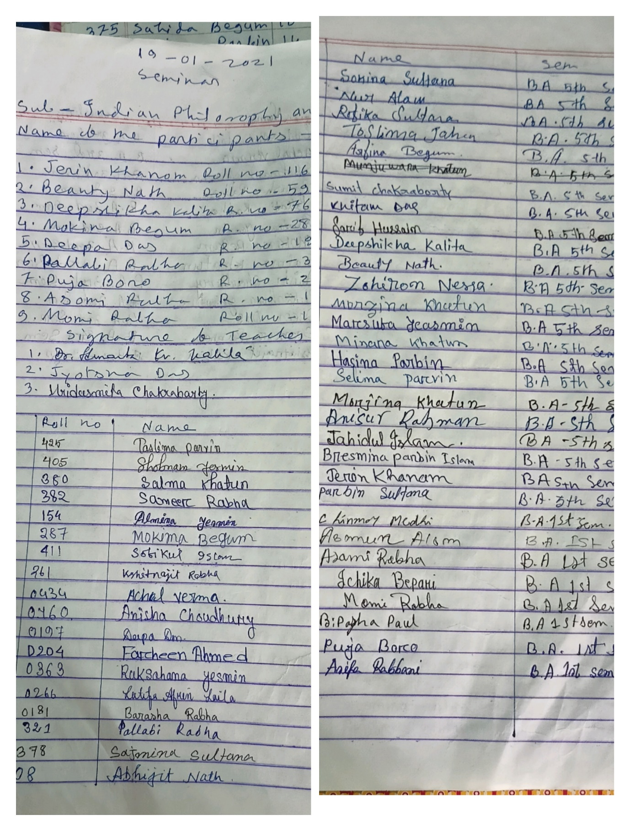

b/ 08/02/2021, Students Present-56, Paper Readers in Group Three. 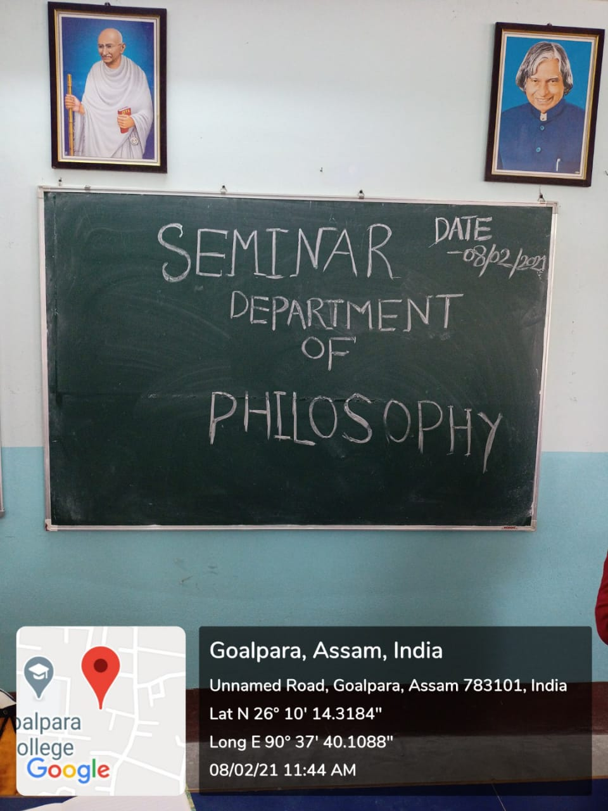
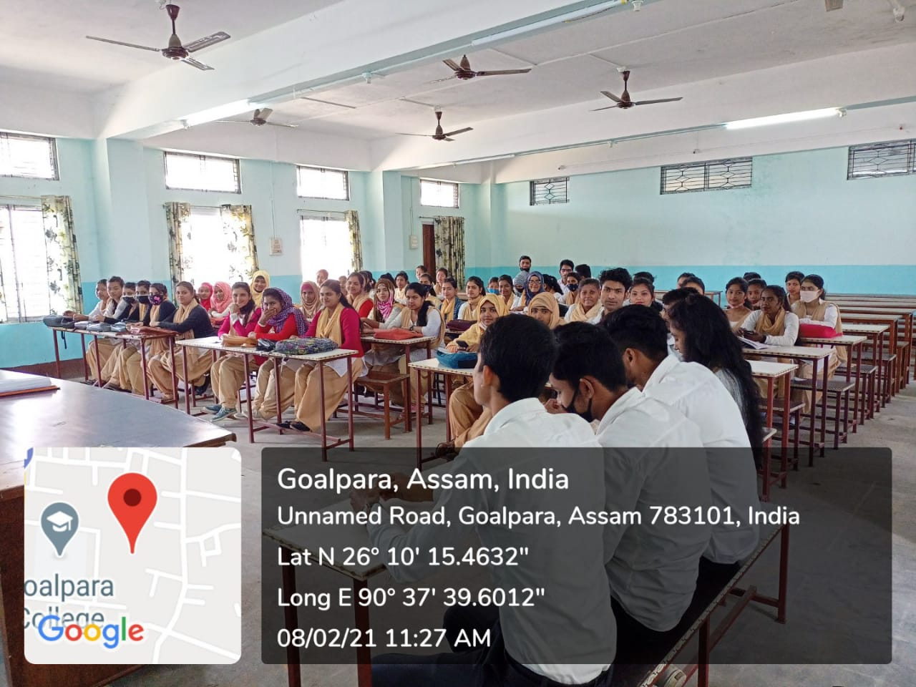

c/ 19/03/2021, Students Present-34, Paper Readers in three.
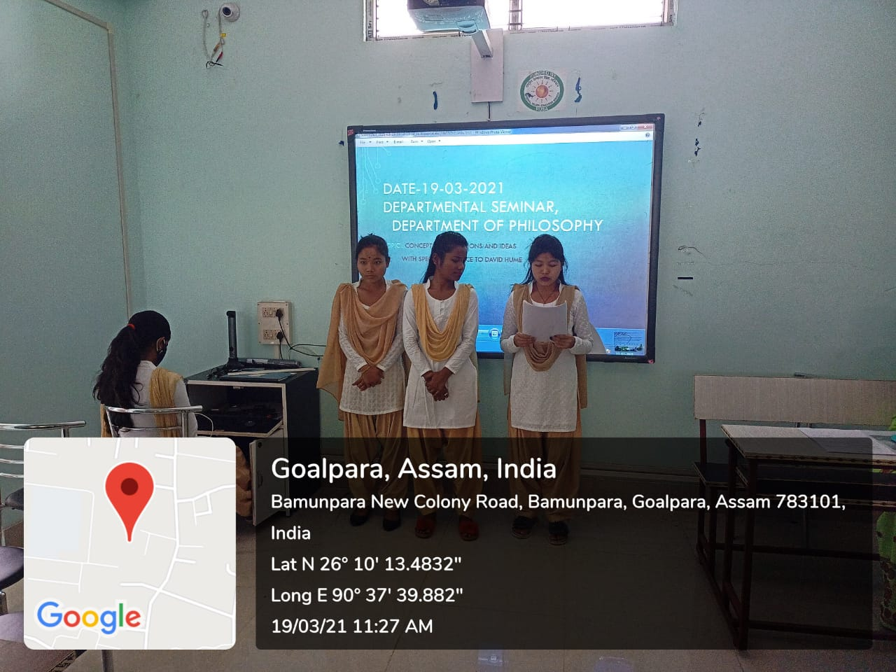
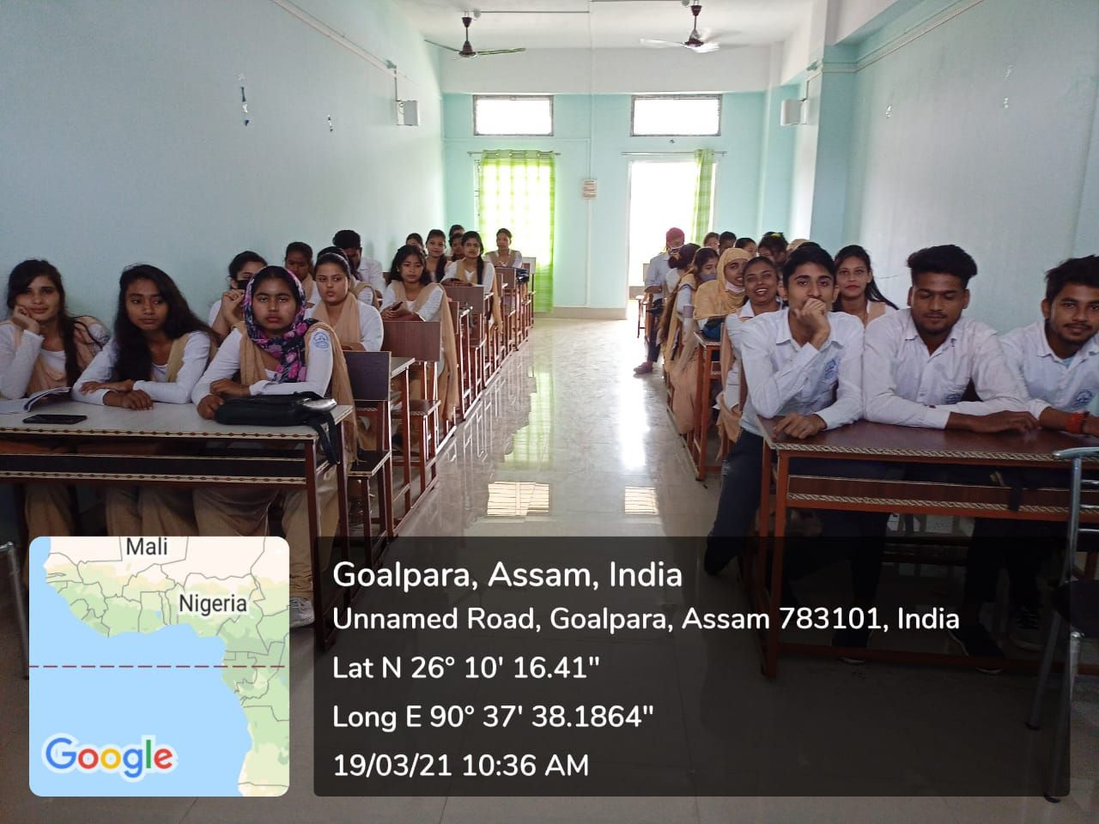
d/ Group Discussion on 22/12/2020 Students Present,65.
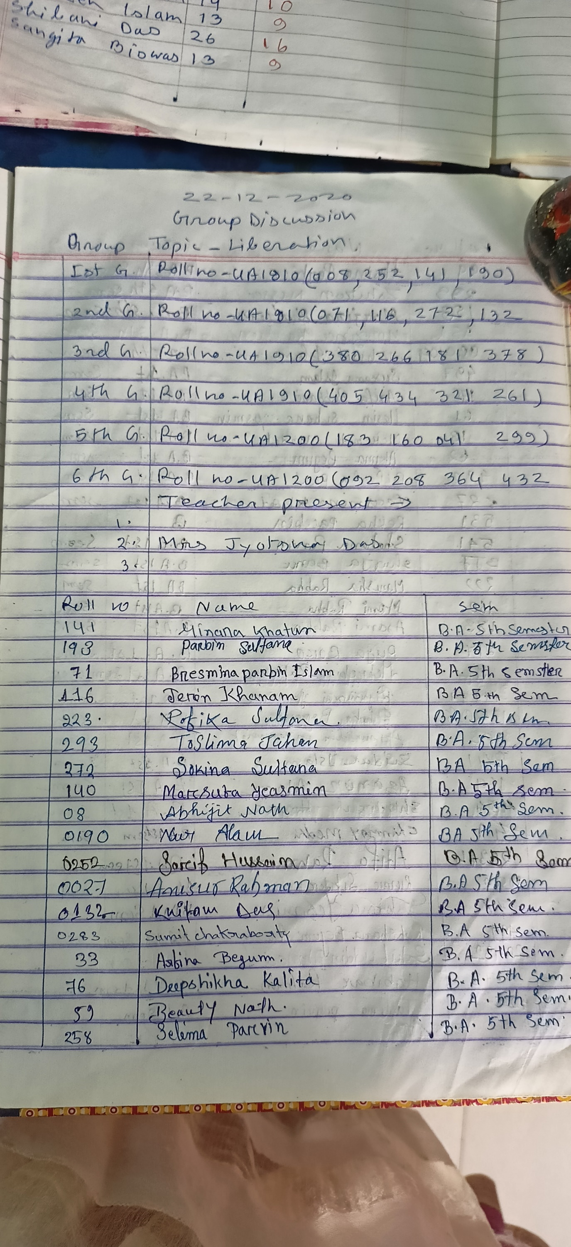
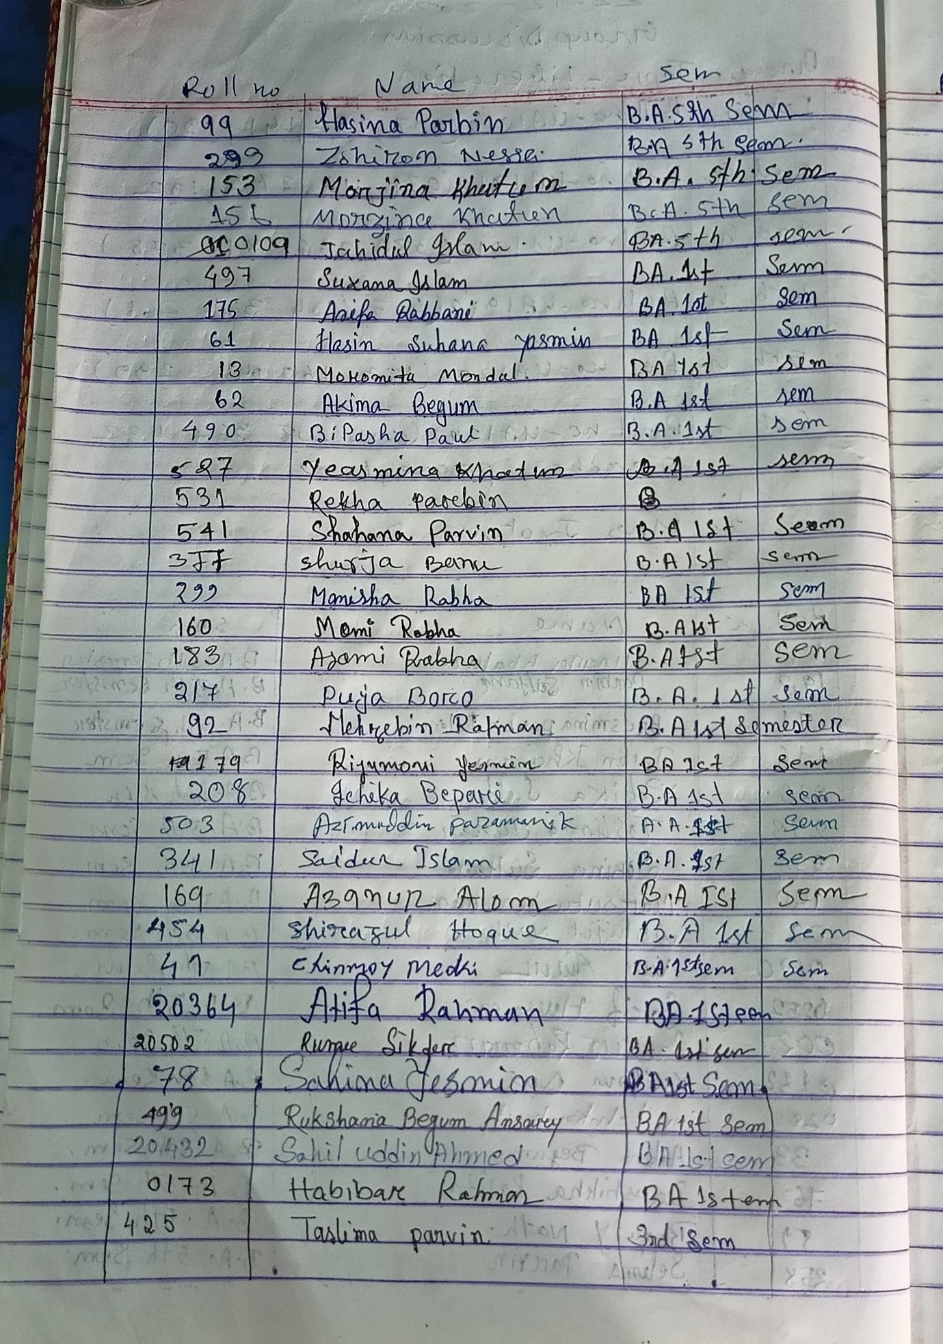
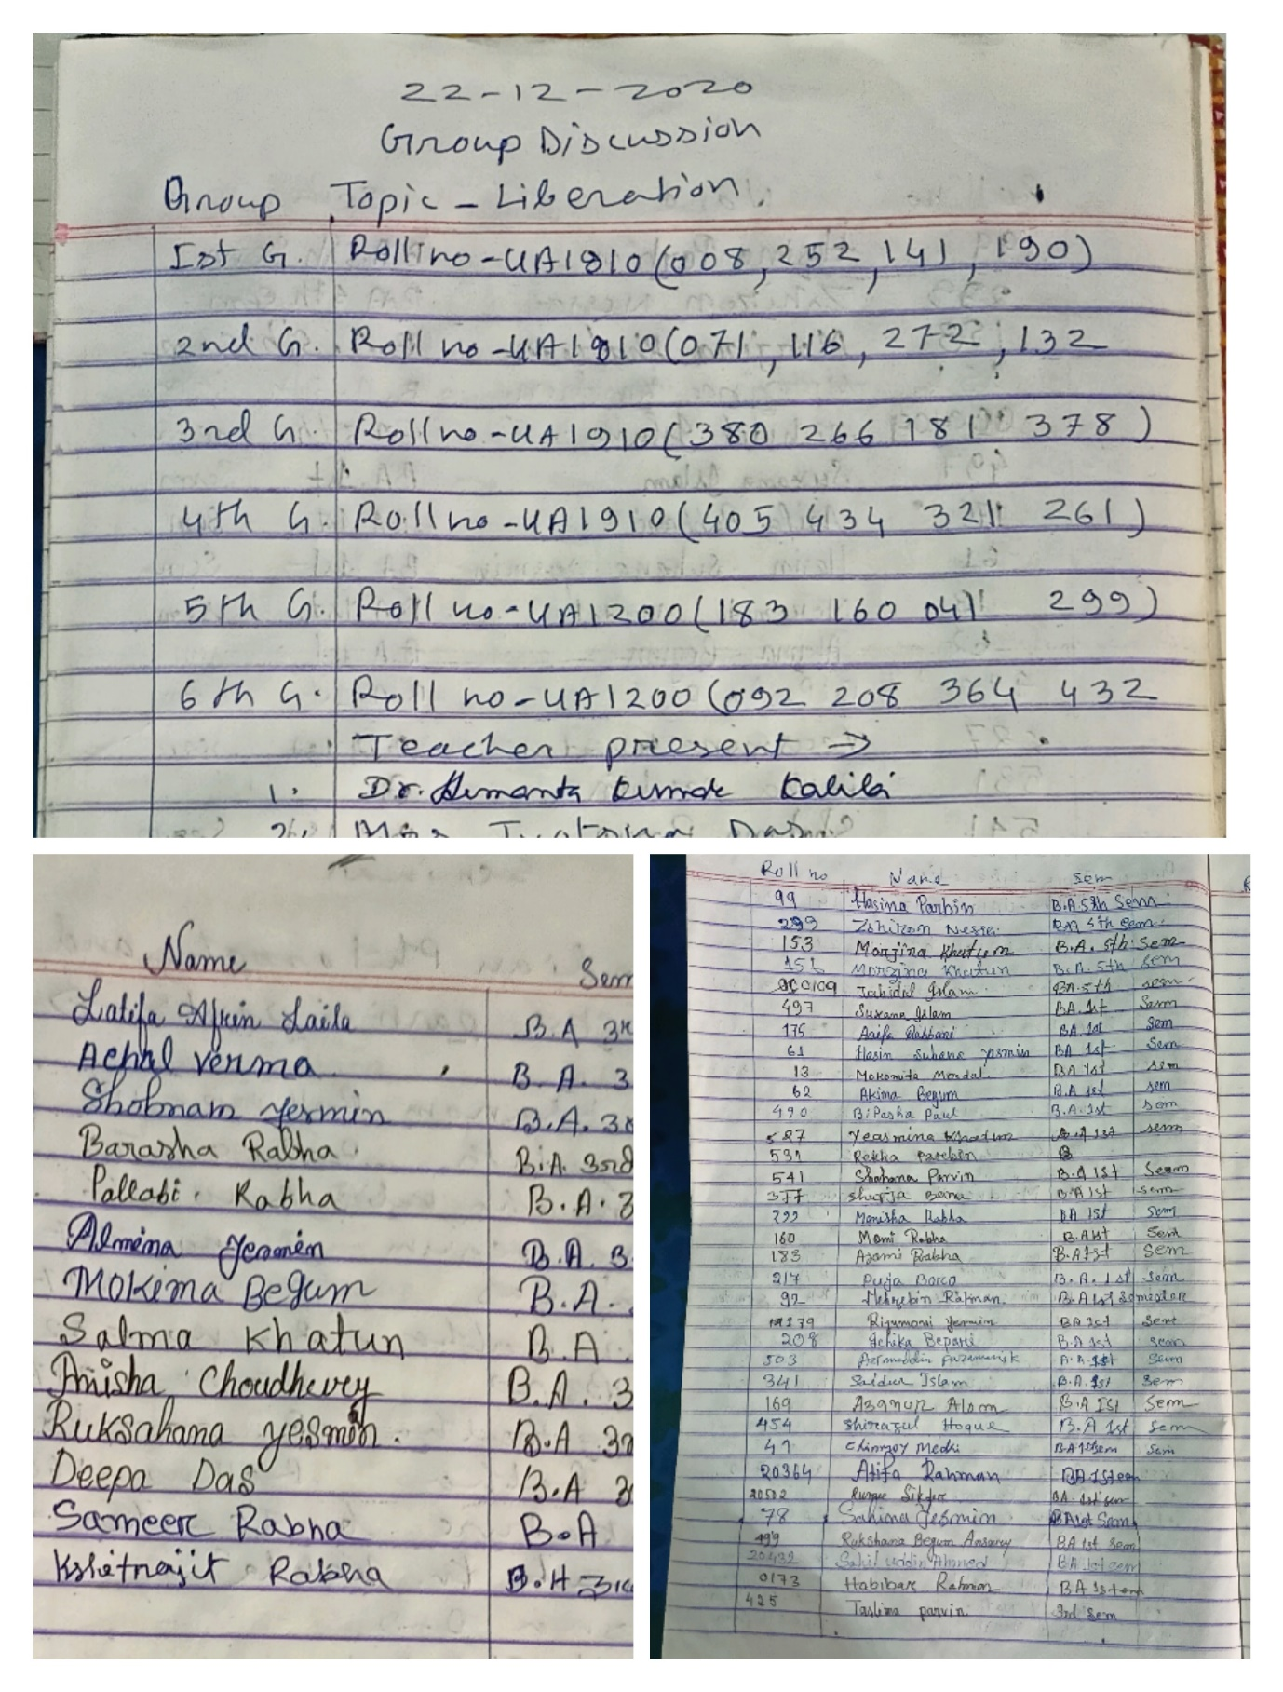
e/ 18/02/2021, Students Present-45
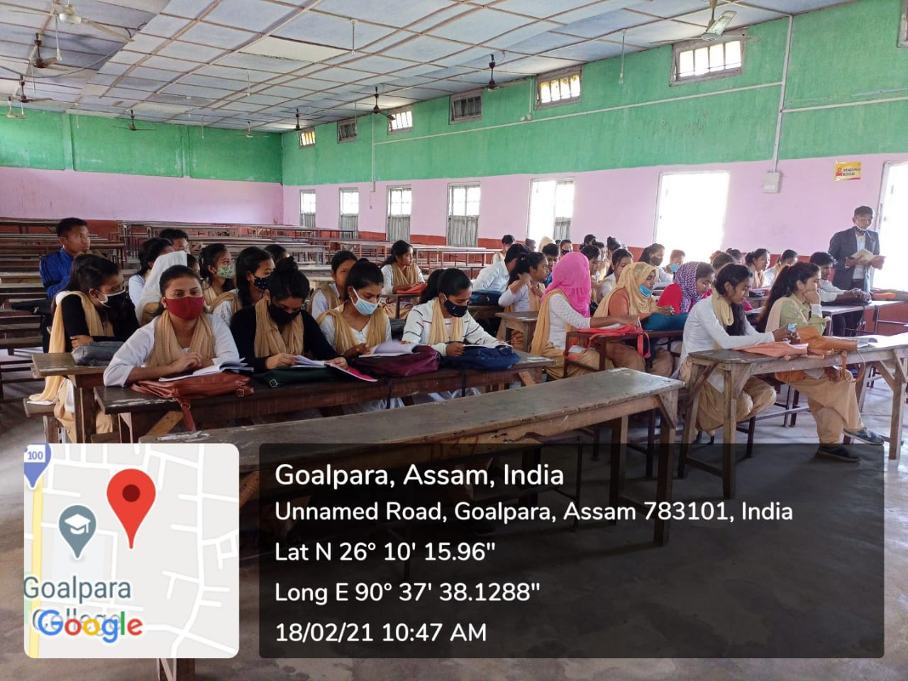
- In order to develop writing skill in examination each faculty is instituting Class Test for Major and Honours students for one hour in Fifteen Marks. Questions are mostly very short type in nature. After seeing the answer scripts students are informed about the marks and their defects and tell them right answer and technique of answering. The some examples have been given in below.

- Educational Tour is organised for Honours Students and Students having Skill in Logic & Philosophy in order to enhance their skill in argumentation, environmental ethics and so on. In the year 2020 department along with students went to Ukiam Meghalaya for the said programme.
- Meeting with the students for constituting mentor and mentee. The purpose of this mentor and mentee relationship was to make more coordination more understanding and more reliability with the teachers. This can surely develop not academic side but also develop morality and respect to others.
- For improvement and for testing student’s performance in examination college authority gives responsibility to Department to commence Sessional Examination for Honours and Major students
- Re examination for those students who obtaining low marks. It is viewed that there are some slow learners among the students who are often getting low marks in sessional Test. But we the faculties are trying our level best to improve their mark, to improve their hand writing and to improve their intellect in particular so that they can forward along with other students.
- It is also observed that a few students are marked as arrear in Final Exam In that case we arrange Special Test for those Students so that they can pass.
- Holding Faculty meet on 3rd April/2021 for assessment of completion of syllabus and discuss for organising a workshop.
- Department feels that if a Workshop on “ How to Prepare and Write Answer in Examination” is arranged for benefit of the students then students will surly take the advantage for preparation and writing answer in the Examination room. Keeping this aim in our mind we invited Dr. Bhanu Bezbora Kalita, HoD Assamese, Goalpara College as Resource Person. As a result the workshop was held on 31/03/2021. Six Faculty Members and 44 students were present in Workshop.
